Irshad, unga career path-ai nenaichu paatha, "Data Filtering" (Option A) dhaan ippo ungalukku romba mukkiyam.
Yen theriyuma? Neenga ippo sales coordination velai panreenga, marine/ship chandling industry-la irukkeenga. Anga lakkanakkaana data irukkum. Ellaa data-vaiyum paakaama, "Evan evan laptop vaangunaan?" illana "Last month evvalavu sales aachu?" nu filter panni edukura thiran (skill) thaan, unga boss-kku neenga kudukura report-ai "Super Report"-a maathum.
🚀 Adutha Step: Python-la Data Filtering (The Analyst's Filter)
Namma pandas_filter.py nu oru file create pannuvom. Inga namma grouped_df-ai filter panni, 500-kku mela sales irukkura products-ai matum edukka porom.
Python
import pandas as pd

# Ithu unga previous grouped_df nu vechukurom
data = {'Product': ['Keyboard', 'Laptop', 'Monitor', 'Mouse'],
'Sales': [100.0, 3000.0, 500.0, 50.0]}
grouped_df = pd.DataFrame(data)

# 1. FILTERING: 500-kku mela Sales irukkurathai matum edukka
high_sales = grouped_df[grouped_df['Sales'] >= 500]

print("High Sales Products (>= 500):")
print(high_sales)
🔍 Enna Nadakkudhu?
- grouped_df['Sales'] >= 500: Ithu computer-kku "Sales 500-kku mela irukkura row-ai ellam 'True' nu solluda" nu command kudukuthu.
- grouped_df[...]: Ithu andha 'True' nu vandha rows-ai matum eduthu unga kitta kodukkum.
💡 Teacher's Note:
Idhu thaan Data Analyst-oda "Search" button. Database-la ayiram records irundhalum, ungalukku vendiya information-ai mattum intha ore line-la eduthudalam.
Task:
- Indha code-ai run pannunga.
- Output-la Laptop (3000) and Monitor (500) mattum vandhu, Keyboard/Mouse poyiducha nu check pannunga.
Result vandhuta, namma adutha stage-ana Power BI connection-kku oru planning pannalam. Ready-a?
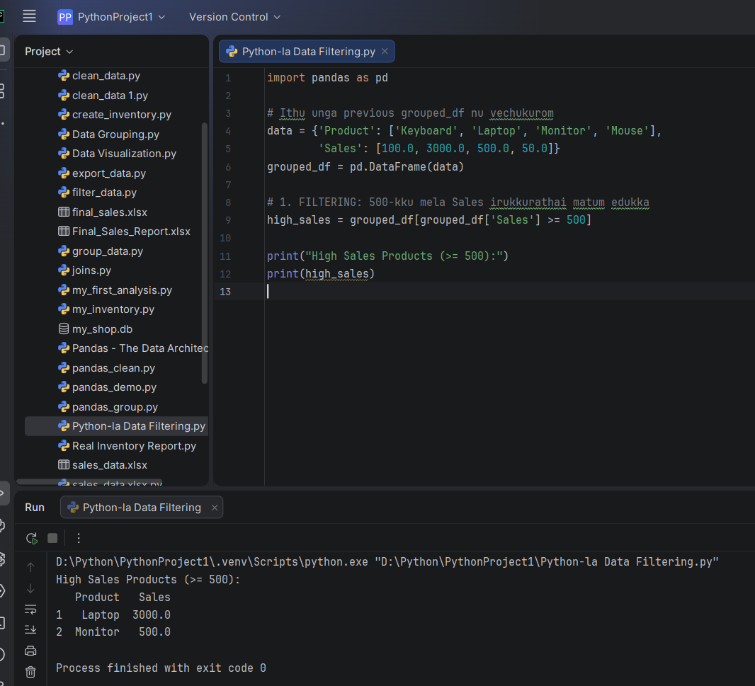
Arumai, Irshad! Neenga "Data Analyst" velaiyai nalla pidichu vachiteenga. Paathiya, Laptop-um Monitor-um mattum azhagaga vandhurukku.
Ippo, namma Data Analyst career-la oru miga periya lakshiya-thukku ready aagiduvom: Python + Power BI Integration.

